Metier description report

Josefine Egekvist, DTU Aqua

26 april, 2019

## Region: Baltic Sea

## Metier: OTB_DEF_>=105_1_120 , years: 2015,2016,2017

Data source: RDB CE and CL data

**Number of trips by flag countries: DEU, DNK, FIN, LTU, LVA, POL, SWE**

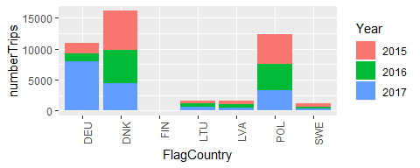

**Top 10 species landed by metier. The rest are summarised in “Other species”. Average yearly landings during the period 2015,2016,2017** 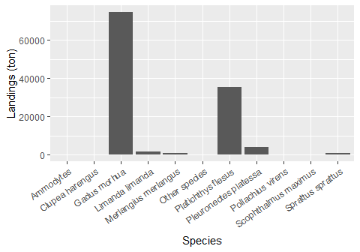

**Number of vessels by vessel length group:**

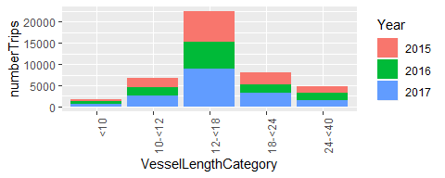

**Seasonal pattern of fishing activity: Number of trips by quarter**

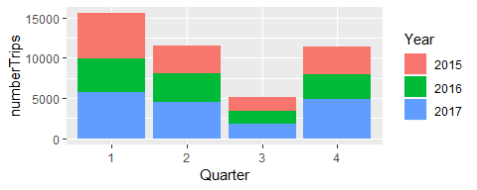

**Days at Sea by ICES rectangle, yearly average 2015-2017** 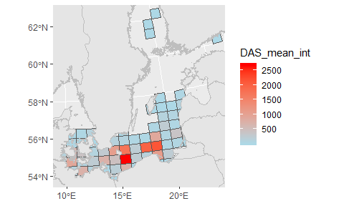

**Comments:**